**UNIT 2 : CLOTHING**

**Lesson 2: Speak**

**I. VOCABULARY:**

1.stripe /straɪp/ (n) : sọc

     + striped (adj) : có sọc

2. - sleeve /sliːv/ (n) : tay áo

+ sleeved /sliːvd/ (adj) : có tay áo

     + sleeveless /ˈsliːvləs/ (adj) : không có tay

     + short-sleeved (adj) : tay ngắn

3. plaid /plæd/ (adj) : có ca-rô, kẻ ô vuông

4. fade /feɪd/ (v) : làm nhạt

Ex: *If you*[*hang*](https://dictionary.cambridge.org/vi/dictionary/english/hang)[*your*](https://dictionary.cambridge.org/vi/dictionary/english/your)[*clothes*](https://dictionary.cambridge.org/vi/dictionary/english/clothes)*out in the*[*bright*](https://dictionary.cambridge.org/vi/dictionary/english/bright)[*sun*](https://dictionary.cambridge.org/vi/dictionary/english/sun)*, they will fade.*

+ fade away : mất dần

+ faded /ˈfeɪ.dɪd/ (adj) : phai màu

5: sweater /ˈswetən(r)/ (n) : áo len

6: baggy /ˈbæɡi/ (adj) : rộng thùng thình

7: plain  /pleɪn/ (adj) : trơn

8. casual clothes /ˈkæʒuəl kləʊðz/ (n) : quần áo thông thường

9. occasion  /əˈkeɪ.ʒən/ (n) : thời điểm một sự việc xảy ra, dịp

+ occasional /əˈkeɪ.ʒənəl/ (adj) : dành cho một dịp đặc biệt

+ on the occasion of st (phr) : vào thời điểm sự kiện nào đó

Ex: *He visited England on the occasion of his daughter’s wedding.*

**II. PRACTICE**

**1: Match the phrases to the pictures on the page 14:**

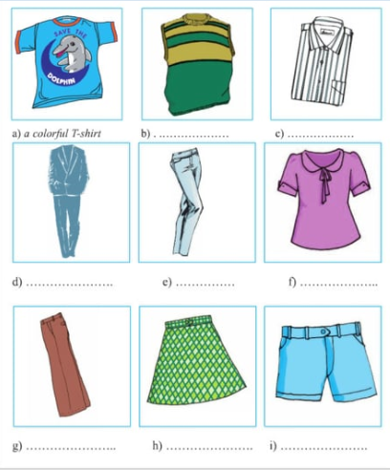

1. a colorful T-shirt

2. a plaid skirt

3. a plain suit

4. a short-sleeved blouse

5. a sleeveless sweater

6. a striped shirt

7. baggy pants

8. faded jeans

9. blue shorts

**2 Complete the conservation with given words in the box:**

|  |
| --- |
| A/ casual clothes B/. What’s your favorite type of clothing?  C/. It’s simple and beautiful D/.Why do you wear these clothes?  E/. I don’t like colorful clothes F/.It makes students to be more polite at school. |

-Erik: What do you usually wear on the weekend?

-Son Tung MTP(STMTP): I usually wear (1)_________________________________, for example a T-shirt and shorts or pants.

-Erik: (2)_____________________________________________________________?

-ST MTP: It’s convenient for me at home.

-Erik: (3)_____________________________________________________________?

-ST MTP: I like the simple clothes: white shirts and dark trousers. (4)________________________________________________because they are not suitable for the Vietnamese people, especially for girls and young women.

-Erik: What do you think of your school uniform?

-ST MTP: (5)____________________________ white shirts and dark pants for boys and white shirt and plain skirts for girls. (6)________________________________________

**3. TAKE A SURVEY:**

|  |  |  |  |  |
| --- | --- | --- | --- | --- |
| **NAME** | **ST1** | **ST2** | **ST3** | **ST4** |
| What do you usually wear on the weekend? Why? |  |  |  |  |
| What’s your favorite type of clothing ? Why? |  |  |  |  |
| Do you like school uniform? |  |  |  |  |
| What do you think of your school uniform? |  |  |  |  |

**Report the results of your survey ________________________________________________________________________________________________________________________________________________________________________________________________________________________________________________________________________________________________________________________________________________________________________________________________________________________________________________________________________________________________________________________________________________________________________________________________________________________________________________________________________**

**III. Homework:**

**-Learn new words by heart.**

**-Practice the survey.**

**-Prepare lesson 3: Listen.**